Robust watermarking algorithm for digital images using discrete wavelet and probabilistic neural network

## **Abstract**

Digital watermarking, which has been proven effective for protecting digital data, has recently gained considerable research interest. This study aims to develop an enhanced technique for producing watermarked images with high invisibility. During extraction, watermarks can be successfully extracted without the need for the original image. We have developed discrete wavelet transform with a Haar filter to embed a binary watermark image in selected coefficient blocks. A probabilistic neural network is used to extract the watermark image. To evaluate the efficiency of the algorithm and the quality of the extracted watermark images, we used widely known image quality function measurements, such as peak signal-to-noise ratio (PSNR) and normalized cross correlation (NCC). Results indicate the excellent invisibility of the extracted watermark image (PSNR = 68.27 dB), as well as exceptional watermark extraction (NCC = 0.9779). Experimental results reveal that the proposed watermarking algorithm yields watermarked images with superior imperceptibility and robustness to common attacks, such as JPEG compression, rotation, Gaussian noise, cropping, and median filter.

## **1. Introduction**

Digitization is occurring worldwide, which can be attributed to the rapid progress and advancement in information technology. This phenomenon exhibits both advantages and disadvantages. The problem regarding the ownership of digital media often draws interest from researchers. Digital information may be copied, attacked, or altered during storage or transmission. Thus, effective watermarking methods that protect digital data need to be developed. Moreover, information should be shared to obtain optimal benefits and utilization. Thus, the security and confidentiality of such information should be seriously addressed.

A digital medium can refer to any kind of digital data, such as text, image, video, or audio. Digital watermarking protects digital media and verifies its legitimate owner. Watermarking was developed from steganography. Both techniques use the concept of embedding information into cover data media ([Ghaleb Al-Jbara et al., 2012](https://www.sciencedirect.com/science/article/pii/S1319157815000658" \l "b0010)).

A watermarking scheme should, at the very least, possess the following qualities: perceptually invisible (or transparent), difficult to remove without seriously affecting image quality, and resistant to image processing attacks. Watermarks can be classified into two main types: visible and invisible. Visible watermarks, such as those used in company logos, are perceptible, whereas invisible watermarks are imperceptible and embedded on unknown areas in the host data. In addition, watermarks can be categorized into two classes according to the processing domain: spatial domain and transform or frequency domain. The former embeds the watermark by directly modifying the pixel values of the original image. Simplicity and ease of implementation are the two advantages provided by spatial domain algorithms over other similar watermarking algorithms ([Zheng et al., 2007](https://www.sciencedirect.com/science/article/pii/S1319157815000658" \l "b0120)). Spatial domain algorithms are less robust than other types of watermarking algorithms because they are more vulnerable to compression, filtering, or noise attacks ([Zheng et al., 2007](https://www.sciencedirect.com/science/article/pii/S1319157815000658#b0120), [Lai and Tsai, 2010](https://www.sciencedirect.com/science/article/pii/S1319157815000658" \l "b0040)). Transform domain methods, such as discrete cosine transform, discrete Fourier transform, and discrete wavelet transform (DWT), embed the watermark by modulating the coefficients of the original image in a transform domain ([Huang et al., 2008](https://www.sciencedirect.com/science/article/pii/S1319157815000658" \l "b0025), [Seng et al., 2011](https://www.sciencedirect.com/science/article/pii/S1319157815000658" \l "b0090), [Seng et al., 2009](https://www.sciencedirect.com/science/article/pii/S1319157815000658" \l "b0085)). The transform domain method is more robust than the spatial domain method against compression, filtering, rotation, cropping, and noise attacks ([Lu, 2005](https://www.sciencedirect.com/science/article/pii/S1319157815000658" \l "b0050)). The wavelet domain, which is a category of the transform domain, is considered an efficient watermark-embedding domain. Embedding an excessive amount of data in the frequency domain can significantly degrade the quality of the watermarked image and result in imperceptibility constraints ([Wang, 2011](https://www.sciencedirect.com/science/article/pii/S1319157815000658" \l "b0100)). In addition, watermarking in the DWT domain has drawn considerable attention because of its desirable time-frequency features and accurate matching of the human visual system ([Kashyap and Sinha, 2012](https://www.sciencedirect.com/science/article/pii/S1319157815000658" \l "b0035)).

Artificial intelligence contributes to the further development of watermarking techniques. Artificial neural networks enhance the performance of conventional watermarking methods by memorizing the relation between the watermark and the corresponding watermarked image.

Several studies ([Huang et al., 2008](https://www.sciencedirect.com/science/article/pii/S1319157815000658" \l "b0020), [Chen and Chen, 2010](https://www.sciencedirect.com/science/article/pii/S1319157815000658" \l "b0005), [Ramamurthy and Varadarajan, 2012](https://www.sciencedirect.com/science/article/pii/S1319157815000658" \l "b0075), [Mei et al., 2002](https://www.sciencedirect.com/science/article/pii/S1319157815000658" \l "b0060)) presented a blind image watermarking scheme that embeds watermark messages into different wavelet blocks according to back-propagation neural networks. Reference ([Zhang, 2009](https://www.sciencedirect.com/science/article/pii/S1319157815000658" \l "b0115)) proposed a blind watermark with the use of the radial basis neural network in the wavelet domain. The watermark can be precisely recovered from the watermarked image without the original and “watermark images.”

Efforts have recently been directed toward the use of probabilistic neural network (PNN) in the wavelet domain. A blind watermarking scheme based on PNNs in the wavelet domain was proposed in [Wen et al. (2009)](https://www.sciencedirect.com/science/article/pii/S1319157815000658" \l "b0105). The statistical properties of the dual-tree wavelet transform were used to embed the watermark bits into edges and textures to achieve watermark safety and imperceptibility. However, the watermark-embedding algorithm depends only on the standard deviations of each coefficient block of the dual-tree complex wavelet transform. Thus, the quality of the watermarked image is degraded after embedding. To our knowledge, this study is thus far the only published work that is based on PNNs in the wavelet domain.

In this work, we propose an imperceptible and robust blind watermarking algorithm based on the PNN in the wavelet domain. The proposed algorithm focuses on maintaining the invisibility and quality of the watermarked image by selecting the best embedding positions in the block-based wavelet coefficient. PNN is then applied to memorize the relation between the watermark and the corresponding watermarked image. Thus, the watermark can be recovered from the watermarked image without the original and watermark images. Experimental results demonstrate that the proposed method performs efficiently in terms of peak signal-to-noise ratio (PSNR) and normalized cross correlation (NCC), as well as exhibits high robustness to various common attacks, such as JPEG compression, rotation, Gaussian noise, cropping, and median filter. These experimental results are finally compared with the results of previous studies.

The remainder of this paper is organized as follows: Section [2](https://www.sciencedirect.com/science/article/pii/S1319157815000658" \l "s0010) describes the proposed algorithm. Section [3](https://www.sciencedirect.com/science/article/pii/S1319157815000658" \l "s0030) presents the experimental results. Section [4](https://www.sciencedirect.com/science/article/pii/S1319157815000658" \l "s0055) concludes the paper.

## **2. Proposed watermarking algorithm**

The proposed algorithm includes three steps: decomposing the cover image, embedding, and extraction. A binary watermark image will be used as the watermark for embedding. The trained PNN is used to extract the watermark during watermark recovery.

### **2.1. Watermark-embedding algorithm**

The watermark-embedding method is shown in [Fig. 1](https://www.sciencedirect.com/science/article/pii/S1319157815000658" \l "f0005). This algorithm essentially includes the following steps: wavelet decomposition, block splitting, watermark embedding, wavelet reconstruction, and watermarked image testing.

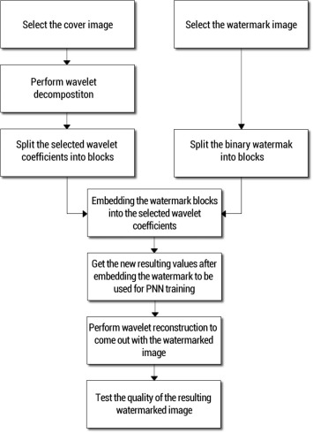

In the algorithm process, three levels of wavelet decomposition are performed for the original cover image with the use of the Haar filter wavelet. The Haar wavelet is well known for its simplicity and speed of computation ([Zheng et al., 2007](https://www.sciencedirect.com/science/article/pii/S1319157815000658#b0120), [Zhang, 2009](https://www.sciencedirect.com/science/article/pii/S1319157815000658#b0115)). In the DWT, the signal passes through two complementary filters and emerges as two signals: approximation and details. This process is called decomposition or analysis. The components can be assembled back into the original signal without loss of information. This process is called reconstruction or synthesis ([Zhang, 2009](https://www.sciencedirect.com/science/article/pii/S1319157815000658#b0115), [MathWorks, xxxx](https://www.sciencedirect.com/science/article/pii/S1319157815000658" \l "b0055)). For image watermarking, the fundamental idea behind the use of wavelets is to conduct an analysis according to scale and time. According to [Lin et al. (2009)](https://www.sciencedirect.com/science/article/pii/S1319157815000658" \l "b0045), the DWT approach is the easiest and most efficient technique for image watermarking. However, the most important aspect of DWT embedding is the selection of the DWT coefficients to be used for embedding and the location in which to embed the watermark within the selected coefficients.

In this study, three levels of 2D-Haar DWT decomposition are used for the original cover image. Haar wavelet uses two types of filters: low-pass and high-pass filters. The output of the low-pass filter is obtained by averaging the inputs, whereas the output of the high-pass filter is the difference of the inputs ([Zhang, 2009](https://www.sciencedirect.com/science/article/pii/S1319157815000658#b0115)).

The proposed method for embedding the watermark is described as follows:

**Step 1:** A grayscale cover image with pixel dimensions of 512 × 512 is first selected.

**Step 2:** A grayscale watermark image with pixel dimensions of 64 × 64 is used as a watermark. The watermark image is then converted into the binary format.

**Step 3:** Three levels of wavelet decomposition are performed for the original cover image with the use of the Haar filter. The DWT processes the image by splitting it into four non-overlapping multi-resolution sub-bands: LL, LH, HL, and HH. The sub-bands LH, HL, and HH (the details) represent the fine-scale of DWT coefficients, whereas the sub-band LL (the approximation) represents the coarse-scale of DWT coefficients. For each successive level of wavelet decomposition, the LL sub-band of the previous level is used as input. Finally, we obtain four sub-bands of three levels, namely, LL3 (cA3), LH3 (cH3), HH3 (cD3), and HL3 (cV3), each of which is 64 × 64 pixels. Moreover, the original image can be reconstructed from these DWT coefficients. This reconstruction process is called the inverse DWT (IDWT).

**Step 4:** The three wavelet sub-band coefficients (cH3, cD3, and cV3) with pixel dimensions of 64 × 64 are split into non-overlapping small blocks with pixel dimensions of 4 × 4. This method produces 16 × 16 blocks for each coefficient.

In this study, the desirable features of wavelet transform are incorporated to gain the maximum benefits. Most of the energy of an image is concentrated in the low-frequency coefficient block LLi ([Nageswararao et al., 2011](https://www.sciencedirect.com/science/article/pii/S1319157815000658" \l "b0070)). Meanwhile, embedding the watermark in the high-frequency coefficient blocks HHi (cH3, cD3, cV3), which represent the fine-scale of DWT coefficients, renders the watermark imperceptible to the human eye.

**Step 5:** The watermark binary image with pixel dimensions of 64 × 64 is split into small, non-overlapping blocks with pixel dimensions of 4 × 2, thus producing 16 × 32 blocks. These blocks are then embedded into the selected wavelet coefficient blocks. However, the watermark is embedded block by block, rather than being converted into a vector, which facilitates embedding. This process includes a reduction in the loop iteration and processing time. This step also enables ease of control and follows the flow of the embedded data.

**Step 6:** Watermark blocks are embedded into the cH3, cD3, and cV3 blocks by the following embedding formula ([Wen et al., 2009](https://www.sciencedirect.com/science/article/pii/S1319157815000658#b0105)):

(1)I′(i,j)=I(i,j)+α(w-1)

where I(i, j) is the original coefficient of the selected block, I′(i, j) is the watermarked coefficient corresponding to I(i, j), w is the watermark bit, and α is the embedding strength coefficient that controls the watermarking strength. The value of α directly influences embedding effectiveness and is selected experimentally.

To ensure high watermarking quality, the watermark blocks (4096 pixels) are embedded in the three wavelet coefficients (cH3, cD3, and cV3) sequentially, as follows:

1.

The first 25% (1024 pixels) of the watermark pixel values are embedded into cH3.

2.

The second 25% (1024 pixels) of the watermark pixel values are embedded into cD3.

3.

The remaining 50% (2048 pixels) of the watermark pixel values are embedded into cV3.

**Step 7:** Inverse decomposition wavelet transform is performed on each coefficient to obtain the watermarked image.

### **2.2. Neural network training**

The PNN is a supervised learning network that implements the Bayes approach for pattern classification in its learning model ([Yu and Chen, 2007](https://www.sciencedirect.com/science/article/pii/S1319157815000658" \l "b0110), [Mishra et al., 2008](https://www.sciencedirect.com/science/article/pii/S1319157815000658" \l "b0065)). PNN selects a learning category and estimates the likelihood of the sample by using the radial basis function. PNN can operate in parallel and requires no feedback from individual neurons for the input; thus, PNN training is instantaneous and easier to learn than other neural networks, such as back-propagation networks ([Zhang, 2009](https://www.sciencedirect.com/science/article/pii/S1319157815000658#b0115)). The PNN consists of four layers of nodes, namely, the input, pattern, summation, and output layers, as shown in [Fig. 2](https://www.sciencedirect.com/science/article/pii/S1319157815000658" \l "f0010). When an input is presented, the first layer computes the distances from the input vector to the training input vectors and then produces a vector with elements that indicate how close the input is to a training input. The summation layer sums these contributions for each class of inputs to produce a vector of probabilities as its net output. Finally, a competitive transfer function on the output of the summation layer selects the maximum of these probabilities and produces a 1 for that class and a 0 for the other classes to obtain the watermark binary image ([MathWorks](https://www.sciencedirect.com/science/article/pii/S1319157815000658#b0055)).

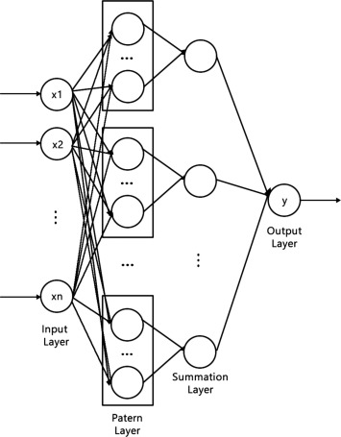

1. [Download high-res image (192KB)](https://ars.els-cdn.com/content/image/1-s2.0-S1319157815000658-gr2_lrg.jpg)
2. [Download full-size image](https://ars.els-cdn.com/content/image/1-s2.0-S1319157815000658-gr2.jpg)

Figure 2. Architecture of PNN.

The training of PNN is conducted by generating a pattern node, connecting it to the summation node of the target class, and assigning the input vector as the weight vector. The values of the three wavelet coefficients (cH3, cD3, and cV3) are combined to form a feature of the training vector with a size of 64 × 64. This feature is used as input to 64 PNNs, for training and extraction.

### **2.3. Watermark extraction algorithm**

Extracting the watermark from the watermarked image is the inverse of the watermark-embedding procedure which is shown in [Fig. 3](https://www.sciencedirect.com/science/article/pii/S1319157815000658" \l "f0015). The trained PNN is used in the extraction process because this network is capable of memorizing the relation between the wavelet coefficients of the watermarked image and a corresponding pixel in the watermark image.

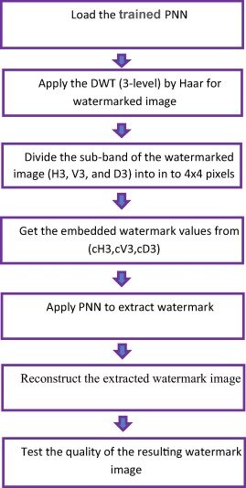

1. [Download high-res image (273KB)](https://ars.els-cdn.com/content/image/1-s2.0-S1319157815000658-gr3_lrg.jpg)
2. [Download full-size image](https://ars.els-cdn.com/content/image/1-s2.0-S1319157815000658-gr3.jpg)

Figure 3. Watermark extraction method.

The watermarked image is first decomposed into three levels by using DWT. These coefficients (cH3, cD3, and cV3) are then divided into small blocks with pixel dimensions of 4 × 4 pixels. The content of these coefficients is then extracted and used as input to the trained PNN to obtain the watermark data. However, the output of each PNN corresponds to a pixel in the watermark binary image.

## **3. Experimental results**

In the experiments, we used 512 × 512 pixel (Lena, Barbara, and Boat) images as cover images. Two different watermark images (UM Logo and Cameraman) of 64 × 64 pixels size are used as the watermark. Performance tests for the proposed algorithm are implemented using MATLAB 2013a on 64-bit Windows 7 OS.

### **3.1. Embedding tests**

The PSNR is used to measure the imperceptibility of the watermarked and the extracted watermark images. PSNR is an example of a function categorized under objective image quality metrics. This function is widely used because of its simplicity and clarity. PSNR is defined by the mean squared error between the corresponding pixel values of the cover (I) and the watermarked image (Iw) [Jalab and Ibrahim, 2012](https://www.sciencedirect.com/science/article/pii/S1319157815000658" \l "b0030):

(2)PSNR=10logmax(I,Iw)2MSE

(3)MSE=1MN∑i=1M∑j=1NI(i,j)-Iw(i,j)2

where max is the maximum possible pixel value of the image. In a grayscale image, this value is equal to 255. The most suitable locations for embedding a watermark are identified on the basis of the experiment results.

In the embedding process, the value of α directly influences the embedding effectiveness. Therefore, the best value for the coefficient α should be identified. The value of α is selected experimentally when applying the proposed algorithm on “Lena” as a cover image and “UM Logo” as the watermark image. The best results for the extracted watermark were obtained by using α = 1, as shown in [Fig. 4](https://www.sciencedirect.com/science/article/pii/S1319157815000658" \l "f0020).

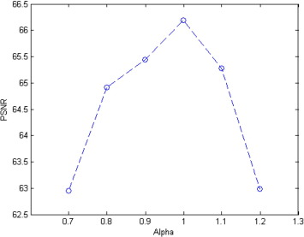

1. [Download high-res image (78KB)](https://ars.els-cdn.com/content/image/1-s2.0-S1319157815000658-gr4_lrg.jpg)
2. [Download full-size image](https://ars.els-cdn.com/content/image/1-s2.0-S1319157815000658-gr4.jpg)

Figure 4. Selection of parameter α relative to PSNR of the extracted watermark.

The performance of the embedding method is evaluated by measuring PSNR, which is used to assess the imperceptibility of the watermarked image.

[Table 1](https://www.sciencedirect.com/science/article/pii/S1319157815000658" \l "t0005) lists the relationship among the cover image, watermark, and PSNR. We find that the PSNR of the watermarked image decreases with “UM Logo,” which proves that the imperceptibility of the watermarked image is proportional to the texture sensitivity of the watermark image, except for any case in which the PSNR is more than 70 dB. This finding indicates that the watermarked image has a good PSNR.

Table 1. Overall performance in the embedding process relative to PSNR.

| **Cover image** | **Watermark** | **PSNR** |
| --- | --- | --- |
| Lena | UM Logo | 70.20 |
| Cameraman | 72.66 |
|  | | |
| Barbara | UM Logo | 70.20 |
| Cameraman | 72.66 |
|  | | |
| Boat | UM Logo | 70.20 |
| Cameraman | 72.66 |

However, [Fig. 5](https://www.sciencedirect.com/science/article/pii/S1319157815000658" \l "f0025) shows no difference between the original image and the corresponding watermarked image, which suggests that the technique enhances the imperceptibility of the watermark.

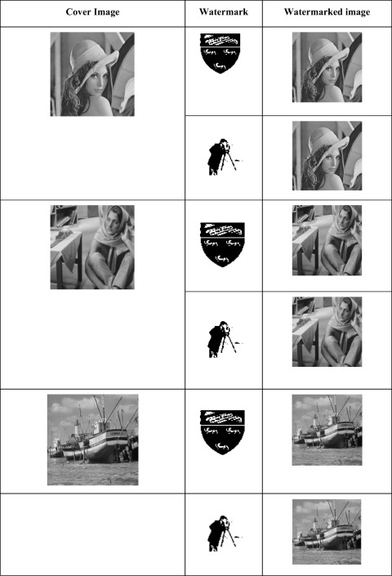

1. [Download high-res image (418KB)](https://ars.els-cdn.com/content/image/1-s2.0-S1319157815000658-gr5_lrg.jpg)
2. [Download full-size image](https://ars.els-cdn.com/content/image/1-s2.0-S1319157815000658-gr5.jpg)

Figure 5. Different cover images used with UM Logo and Cameraman binary watermark.

### **3.2. Extraction tests**

The performance of the extraction method is evaluated by measuring imperceptibility and robustness. The NCC is used to measure the image quality of the watermark after extraction, as given by [Temi et al. (2005)](https://www.sciencedirect.com/science/article/pii/S1319157815000658" \l "b0095).

(4)NCC=∑i∑jW(i,j)·W′(i,j)∑i∑jW2(i,j)

where W(i, j) and W′(i, j) are pixel values at the i, j locations of the original watermark and the extracted watermark image, respectively.

To test the effectiveness of the extraction algorithm, the inputs of PNN response to the watermarked image are considered. [Table 2](https://www.sciencedirect.com/science/article/pii/S1319157815000658" \l "t0010) summarizes the results obtained using different input vector sizes of PNN in the attack-free case. In this test, a 512 × 512 pixel gray Lena image is used as a cover image, whereas a 64 × 64 pixel binary image of the UM Logo is taken as a watermark.

Table 2. Quality of watermark extraction on the basis of the number of input bits of the neural network.

| **Inputs of PNN** | **Time (s)** | **NCC** | **PSNR** |
| --- | --- | --- | --- |
| 256 | 1.28 | 0.8953 | 60.63 |
| 128 | 2.03 | 0.9270 | 63.80 |
| **64** | **3.26** | **0.9779** | **68.27** |
| 32 | 5.93 | 0.9790 | 72.21 |
| 16 | 11.36 | 0.9889 | 77.26 |
| 8 | 21.93 | 0.9948 | 83.65 |

According to [Table 2](https://www.sciencedirect.com/science/article/pii/S1319157815000658#t0010), the extraction quality of the watermark images is degraded as the number of PNN inputs increases. This effect is observed because an increasing number of PNN inputs indicates fewer neural networks available for the extraction of the watermark, such that the accuracy and execution time of PNN will decrease. However, when the number of PNN inputs decreases, more neural networks can be used for the extraction of the watermark, such that the accuracy and extraction time of PNN will increase. The computational complexity of embedding and extracting is an important attribute of watermarking. Embedding can be quickly and easily performed, whereas extraction can be time-consuming. The selection of an appropriate extracted image quality is a key consideration for extraction algorithms. Excellent watermarks with high NCC and PSNR values should be extracted for various aspects of watermarking algorithms, which prioritize image quality over speed. Image quality may have to suffer in exchange for speed, or vice-versa. In this study, we used 64 inputs to each PNN for training and extraction. [Table 2](https://www.sciencedirect.com/science/article/pii/S1319157815000658#t0010) shows the optimal image quality, with reasonable computational time relative to the other cases.

### **3.3. Robustness testing**

To prove the robustness of the proposed algorithm, we investigated the effect of the following attacks on watermarked images:

(a)

JPEG compression (quality factor = 70, 50, and 10).

(b)

Image rotation (with rotation angle = 5° and 45°).

(c)

Gaussian noise (with standard deviation σ = 20 and 50).

(d)

Image cropping (up to 25%).

(e)

Median filter.

[Table 3](https://www.sciencedirect.com/science/article/pii/S1319157815000658" \l "t0015) illustrates the results of watermark image extraction after different types of image processing attacks.

Table 3. Overall performance of watermark images extracted after: (a) JEPG compression, (b) rotation, (c) Gaussian noise, (d) cropping, and (e) median filter attacks.

| **Watermark images** | | **https://ars.els-cdn.com/content/image/1-s2.0-S1319157815000658-fx1.jpg** | | **https://ars.els-cdn.com/content/image/1-s2.0-S1319157815000658-fx2.jpg** | |
| --- | --- | --- | --- | --- | --- |
| **Image processing attacks** | **Intensity** | **Extracted watermarks** | | **Extracted watermarks** | |
| **NCC** | **PSNR** | **NCC** | **PSNR** |
| (a) JPEG | Q = 70 | 0.8451 | 59.10 | 0.9572 | 60.45 |
| Q = 50 | 0.7520 | 57.20 | 0.9451 | 58.64 |
| Q = 10 | 0.4395 | 54.43 | 0.8910 | 56.20 |
|  | | | | | |
| (b) Rotation | 5° | 0.9251 | 62.55 | 0.9841 | 64.60 |
| 45° | 0.8965 | 60.25 | 0.9762 | 62.14 |
|  | | | | | |
| (c) Gaussian noise | σ = 20 | 0.9753 | 67.04 | 0.9924 | 68.13 |
| σ = 50 | 0.9863 | 67.48 | 0.9928 | 68.15 |
|  | | | | | |
| (d) Cropping | Left upper side (25%) | 0.6660 | 56.46 | 0.9096 | 58.77 |
| Right lower side (25%) | 0.9023 | 60.48 | 0.9868 | 63.31 |
|  | | | | | |
| (e) Median filter |  | 0.9329 | 62.38 | 0.9837 | 63.91 |

In the test extraction process, each attack has been tested with each previously described watermarked image. [Fig. 6](https://www.sciencedirect.com/science/article/pii/S1319157815000658" \l "f0030)a–e shows the watermarked Lena image, as well as the extraction results for the two watermark binary images (UM Logo and Cameraman), after JEPG compression, cropping, Gaussian noise, rotation, and median filter attacks.

The extracted mages are partially degraded after JPEG, rotation, and cropping attacks. However, the extracted watermark images remain recognizable because these attacks change the indexed reference values, which may contain the watermark location values of the embedded values. Thus, during data retrieval, the retrieved extracted values may not be the watermark values of the indexed location values, which have been changed. This outcome can also be observed in [Fig. 6](https://www.sciencedirect.com/science/article/pii/S1319157815000658#f0030)a–c. In addition, the algorithm is evidently robust against Gaussian noise, rotation, and median filter attacks because the extracted watermark was not significantly affected, as shown in [Fig. 6](https://www.sciencedirect.com/science/article/pii/S1319157815000658#f0030)d and e.

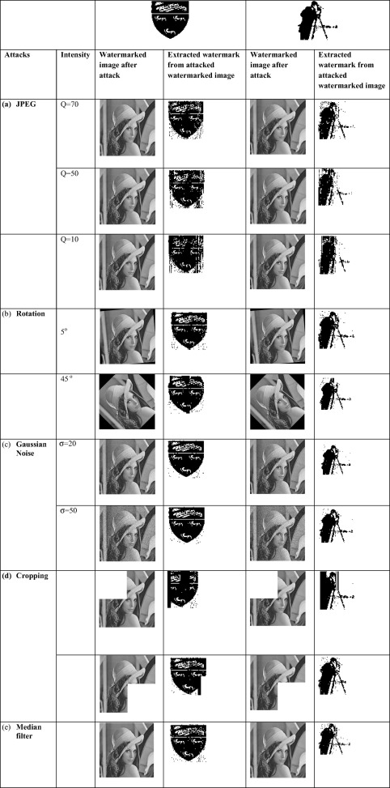

1. [Download high-res image (919KB)](https://ars.els-cdn.com/content/image/1-s2.0-S1319157815000658-gr6_lrg.jpg)
2. [Download full-size image](https://ars.els-cdn.com/content/image/1-s2.0-S1319157815000658-gr6.jpg)

Figure 6. Logo extracted after (a) JEPG compression, (b) rotation, (c) Gaussian noise, (d) cropping, and (e) Median filter attacks.

### **3.4. Comparison with similar techniques**

To confirm its validity, the proposed method is compared with other methods under approximately the same conditions. [Wen et al. (2009)](https://www.sciencedirect.com/science/article/pii/S1319157815000658#b0105) proposed a blind digital watermarking algorithm based on PNN.

The main differences are as follows:

1.

The algorithm by Wen et al. embeds the watermark by decomposing the cover image using dual-tree wavelet transform, after which the watermark bits are added to the selected coefficient blocks. By contrast, in our work, three levels of wavelet decomposition are performed for the original cover image with the use of the Haar filter.

2.

The algorithm by Wen et al. uses the standard deviation of each wavelet coefficient to verify whether the block can be used for embedding the watermark. Thus, the quality of the watermarked image is degraded after embedding. Meanwhile, our approach resolves the degradation of the quality of the watermarked image after embedding by using embedding Formula [(1)](https://www.sciencedirect.com/science/article/pii/S1319157815000658" \l "e0005) to embed the watermark blocks into the cH3, cD3, and cV3 blocks. Moreover, the embedding of the watermark blocks into cH3, cD3, and cV3 is performed sequentially as follows: The first 25% of the watermark pixel values are embedded into cH3, the second 25% of the watermark pixel values are embedded into cD3, and the remaining 50% of the watermark pixel values are embedded into cV3.

3.

Wen et al. used 3 × 3 neighbors of watermarked coefficients as input to PNN, with the output signals as the watermark data. However, our algorithm uses 64-bit watermark pixel values, which are embedded into cH3, cD3, and cV3, as an input to the PNN, thus making the extraction process faster.

As shown in [Table 4](https://www.sciencedirect.com/science/article/pii/S1319157815000658" \l "t0020), the proposed algorithm performs more efficiently than the aforementioned methods ([Huang et al., 2008](https://www.sciencedirect.com/science/article/pii/S1319157815000658#b0025), [Wen et al., 2009](https://www.sciencedirect.com/science/article/pii/S1319157815000658#b0105), [Gunjal et al., 2011](https://www.sciencedirect.com/science/article/pii/S1319157815000658" \l "b0015), [Ramamurthy and Varadarajan, 2012](https://www.sciencedirect.com/science/article/pii/S1319157815000658" \l "b0080)). This performance is verified by the extracted watermark results, which demonstrate that the algorithm can maintain the quality of the watermarked image after embedding. The function values of image quality measurement also confirm this result. Thus, the watermarked image produced by the proposed algorithm has better imperceptibility than that obtained using similar techniques because the PSNR values indicate that the watermarked image and the original image are identical.

Table 4. Comparison of invisibility of the extracted watermark image obtained by the proposed algorithm and that obtained by using other approaches.

| **Author** | **Extraction algorithm based on** | **Cover image size** | **Watermark size** | **PSNR** | **NCC** |
| --- | --- | --- | --- | --- | --- |
| Proposed | Probabilistic neural network | 512 × 512 | 64 × 64 | 68.27 | 0.9779 |
| [Wen et al. (2009)](https://www.sciencedirect.com/science/article/pii/S1319157815000658#b0105) | Probabilistic neural network | 512 × 512 | 64 × 64 | 36.7 | 0.9790 |
| [Ramamurthy and Varadarajan (2012)](https://www.sciencedirect.com/science/article/pii/S1319157815000658#b0080) | Quantization and back propagation neural network | 512 × 512 | 64 × 64 | 48.2396 | 0.9781 |
| [Gunjal et al. (2011)](https://www.sciencedirect.com/science/article/pii/S1319157815000658" \l "b0015) | Direct weighting factors | 512 × 512 | 64 × 64 | 48.53 | Closes to 1 |
| [Huang et al. (2008)](https://www.sciencedirect.com/science/article/pii/S1319157815000658" \l "b0025) | Back propagation neural networks | 256 × 256 | 64 × 64 | 43.55 | Closes to 1 |

## **4. Conclusion**

This study proposes a blind digital watermarking algorithm based on PNN in the wavelet domain. The proposed algorithm maintains the invisibility and quality of the watermarked image. The developed algorithm is a blind watermarking technique that meets the requirements of invisibility and robustness. Watermarking is performed by embedding a watermark in the middle-frequency coefficient block of three DWT levels. The PNN is used during watermark extraction. The results confirm the excellent invisibility of the extracted watermark image (PSNR = 68.27 dB), as well as the satisfactory extraction of the watermark (NCC = 0.9958). The proposed algorithm is superior to other existing techniques reported in the literature in terms of invisibility.

Different tests were conducted to verify the robustness of the watermarked image. Tests involved the use of various common attacks such as JPEG compression, rotation, Gaussian noise, cropping, and median filter against the watermark. The watermarks were successfully extracted in all tests, but the qualities of the extracted watermarks varied depending on the type of attack to which they were subjected.